Cache Tag

Cache memory of any kind is subdivided for so-called lines. It’s unreasonable to provide every single byte in cache with an address field indicating its location in operating memory because it would lead to terrible consequences in means of manufacturing costs. If to consider a 32-bit linear physical address space which allows for up to 4Gb of operating memory, every single cache byte must be supplied with 4 bytes for addressing needs this way! Additionally, such a cache would be poor very much in means of performance. Thus, it's much wiser to address certain sets of adjacent bytes which would form cache lines. In real life, these lines are sized at 32 or 64 bytes each usually, however could be found as large as 1024 bytes each. Of course, any line size must be a positive integer power of two. Nevertheless, even if size requirement has been met, not any set of adjacent bytes may be cached because of an additional limitation known as address alignment. In other words, a set of adjacent bytes may be placed into a cache line if and only if its starting address is aligned at the line size boundary. To throw an example in, a 32-byte cache line may only be filled with information from operating memory located at hexadecimal (decimal) addresses of 00-1F (00-31), 20-3F (32-63), 40-5F (64-95) and so on. Apart of other benefits, this simple rule allows to reduce number of address bits required per line. To be absolutely correct, by 5 in the example above, i. e. log₂(32) = 5. Finally, a cache line must either be loaded fully with some valid information or be empty completely which means the same to be loaded with invalid information. So, it cannot carry any partial content. There is only one exception to this rule: if two cache lines share one address field, they may be considered as sub lines of one large line, and they're independent to some extent from each other.
Every address field consists of two primary parts: a dynamical (tag) which contains the higher address bits, and a statical (index) which contains the lower address bits (nota bene: do not associate with dynamic and static memory cells, that's different). The first one may be modified during run-time while the second one is fixed. To explain what these parts are for, it needs to introduce logical memory segmentation. Imagine that there is some physical memory space which is organised in form of M memory segments sized equally. Suppose that those memory segments and cache segments are exactly of the same size. Every memory segment contains N memory lines, of course, sized equally. Once again, suppose that those memory lines and cache lines are exactly of the same size. Therefore, to obtain an address of a memory line, it needs to determine the number of its memory segment first and the number of the memory line inside of that segment second, then to merge both numbers. Substitute the segment number with the tag and the line number with the index, and you should have realised the idea in general.
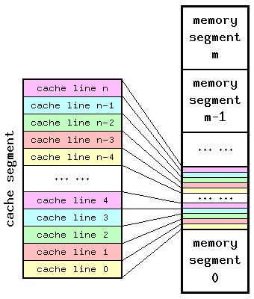
Therefore, cache line's tag size depends on 3 factors:
- size of cache memory;
- associativity of cache memory;
- cacheable range of operating memory.
Index size depends only on cache segment size and line size. Actually, it must be big enough to enumerate all lines within any particular segment. For instance, if there is 512Kb cache segment with 32-byte line size, index size is log₂(512Kb / 32b) = 14 bits. In a matter of fact, every cache line within a particular segment has a dedicated number assigned and hardwired. It cannot be changed and there is no need to. If there are N cache segments, there must always be N cache lines carrying a similar index. If to keep segment size intact, line size increase imposes index size decrease as well as reduction on total number of index fields because of reduction on total number of lines involved. However, larger lines feature higher load/store latencies while transferring from/to other caches or operating memory since bandwidth of any bus interface is well finite. Additionally, larger lines decrease caching efficiency because of higher level of pollution with unnecessary information.
After all, every cache line is provided usually with some redundant information for proper error detection. Data fields are protected usually with either parity checking on byte level or one of error checking and correcting (ECC) protocols on field level, most of which are based upon the Hamming algorithm. Tags may be protected with single-bit parity checking, though it isn't nearly as mandatory as in case of data fields. Whatever a particular implementation of error detection is, any fault protecting logic adds some complexity to an original design and gets transaction latencies affected inevitably. That is, a control sum of data field has to be recalculated and compared to the stored one on every read. The worst case is partial write into a valid line because a control sum has to be calculated twice: before and after the line change.

When the processor is first switched on, the cache will not contain valid data. So a valid bit is associated with each cache location, and is set when data is written. Lots of memory locations are mapped to the same cache location. We also need to know which location is currently in the cache. We do this with a cache tags. The cache tag is the remaining bits of the address.To discover whether a data reference hits or misses the cache:
1 find the cache index of the address
2. match the cache tag with the cache tag part of the address
100110
Cache index is 110 -> cache tag is 100
Cache tag part of 100110 is 100
100 == 100 -> hit
010011
Cache index is 011 -> cache tag is 000
Cache tag part of 010011 is 010
000! = 010 -> miss
To increase the size of the cache we can either increase the number of positions, or increase the size of the data stored at those positions
Example of a cache with 32 entries each 32 bytes of data:

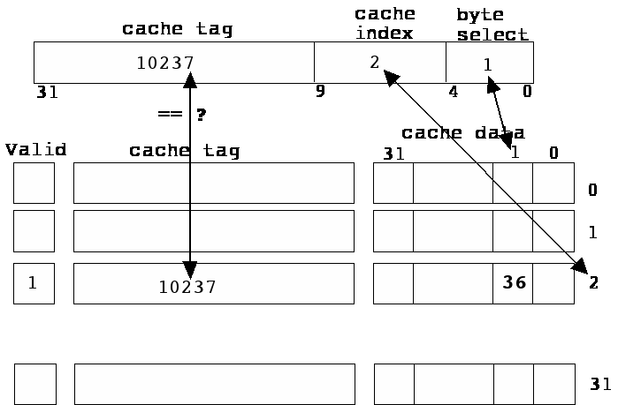

Increasing the number of bytes for each cache entry involves a penalty when there is a miss. More bytes need to be copied from memory into the cache. Spatial locality means that this is not necessarily a bad thing!
Using the cache index to find the correct data line before comparing the cache tag involves two levels of computation. A fully associative cache combines the cache index with the cache tag.

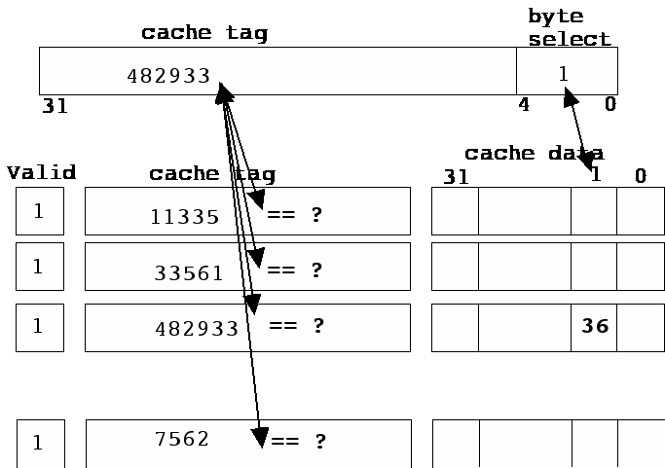

To find out whether the data is in the cache:
Compare the cache tag part of the memory address with all the cache tags in the cache.
This matching is done in parallel in a fully associative cache.

